Class-D Stereo Amplifier
SM6802 Study

Spreading:

société / CENTRE / URD | Name
NBBSE
 | Jean-Claude Berge | HW Manager
 | Yu Bichun | Base Band
 | Shen Bo | Base Band
 | Nie Huazhe | Base Band
 | Yu Jianbing | Base Band
 | Kong Qingde | Base Band
 | Wei Xiaosan | Base Band
 | Zhao Zhanke | Base Band
 | Nies Pheng | Base Band
SAGEM
BIRD

VISAS
Writer | Team Leader | Hardware Manager
Name: Zhao Zhanke | Name: Nies Pheng | Name: Jean-Claude Berge
Date: 2005-03-20 | Date: 2005-03-24 | Date:
Visa:Validate | Visa:  Validate | Visa:

History OF THE revisions

Index | Date | Author | Modification
A | 2005-03-20 | Zhao Zhanke | Creation of the document

Synthesis

Conclusions can be drawn by test the SM6802 demo board:

(1)Consumption when SM6802 in power-down mode is 0.44mA, this consumption is too big.
(2)There is much noise when using demo board to amplify the music.

Where to find this document

\\NBSrv_RD2\RD_Project\33_Baseband\Project_study

TABLE OF CONTENTS

1. Object 4
2. CLASS-D sTERREO AMPLIFIER—SM6802 4
2.1.1. BLOCK DIAGRAM OF SM6802 4
2.1.2. FEATURES OF SM6802 4
2.1.3. PIN FUNCTION OF SM6802 4
3. TEST ON SM6802 DEMO BOARD 5
3.1. Consumption test 5
3.2. audio quality test 7
4. Conclusion 8

Object
This document is manly to test the characters of Class-D stereo Amplifier SM6802.

CLASS-D sTERREO AMPLIFIER—SM6802

BLOCK DIAGRAM OF SM6802

The block diagram is figure 1.
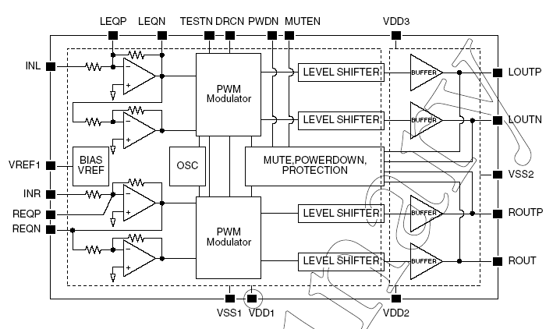
Figure 1 Block Diagram of SM6802

FEATURES OF SM6802

Features of SM6802 are below:
(1)Operating supply voltage: 2.7V to 5.5V
(2)Low current consumption: 8mA
(VDD1=VDD2=VDD3=3.6V, 8 load)
(3)Output power: 0.5W+0.5W
(VDD1=VDD2=VDD3=3.6V, 8 load)
(4)Gain
6dB (Normal)
15dB to 6 dB automatic adjustment in response to the input level
(Dynamic range compression mode)
(5)Silicon-gate CMOS process
(7)Package: 20-pin QFN

PIN FUNCTION OF SM6802

Pin description of SM6802 is table 1.

Table 1 Pin Description of SM6802
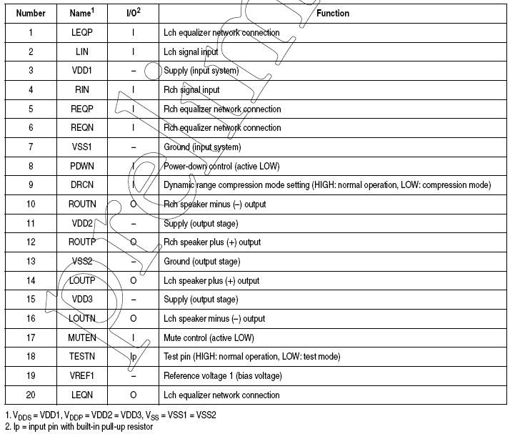

TEST ON SM6802 DEMO BOARD

Test Measurement:
- DC POWER(TTi)
- Accurate Multi-meter(R6552)
- Music source(Recorder)
- Two 8 speakers

Test Voltage: 4.0V

Consumption test

The circuit of SM6802 demo board is figure 2.

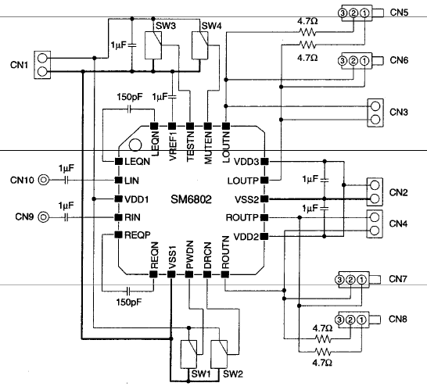
Figure 2 Circuit of DEMO Board

Here, we connect the CN1 and CN2 to DC Power (supply voltage is 4.0V), CN6 is connected to 8 load (speak), CN7 is connected to 8 load (speaker).

Consumption is tested, result is table 1.

Table 1 Consumption Test on SM6802 DEMO BOARD
Symbol | Condition | Value | Unit
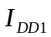 | PDWN=HIGH,MUTEN=HIGH  DRCN=HIGH | 0.44 | mA
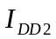 | PDWN=LOW,MUTEN=LOW  DRCN=HIGH | 9.55mA | mA
According the specification of SM6802, table 2 can be got:

Table 2 DC Characters of SM6802
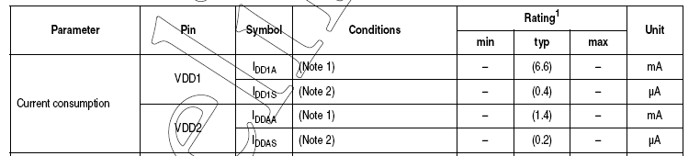
From table 2, we can find that the typical current of should be 0.6uA, the typical current of should be 8mA. This is not consistent with table 1.

From table 1, conclusions can be drawn below:

(1) When SM6802 in power-down mode (PDWN is high), the consumption of SM6802 is 0.44mA;

(2) When SM6802 in active mode (PDWN is low), the consumption of SM6802 is 9.55mA.
When SM6802 in power-down mode, consumption of SM6802 is 0.44mA, I think this is too big for mobile when mobile in idle mode or in sleep mode.

(3)The polarity of PDWN is opposite to that of normal PDWN.
When PDWN of SM6802 is high, SM6802 is in idle mode; but when PDWN of SM6802 is low, SM6802 is in active mode (SM6802 begin to work).

audio quality test

When DRCN (the ninth pin of SM6802) is high, there is much noise in music ;but when DRCN is low, there is lower noise In music(but quality of music is worse than AB audio amplifier).

What is the function of test pin(the 18th pin of SM6802)?when the test pin is connected to high, noise in music is big

Signal is tested on LOUTP (the 14th pin of SM6802) and LOUTN (the 16th pin of SM6802) when mobile in different mode.
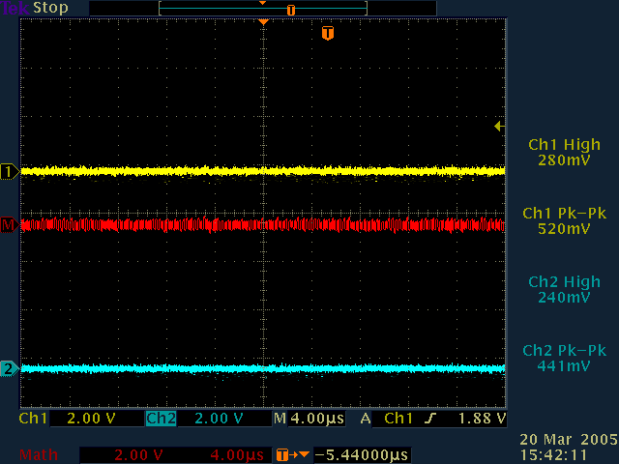
LOUTN1
LOUTP
LOUTP-LOUTN

Figure 3 CH1=LOUTP CH2=LOUTN WHEN PDWN Is High Level

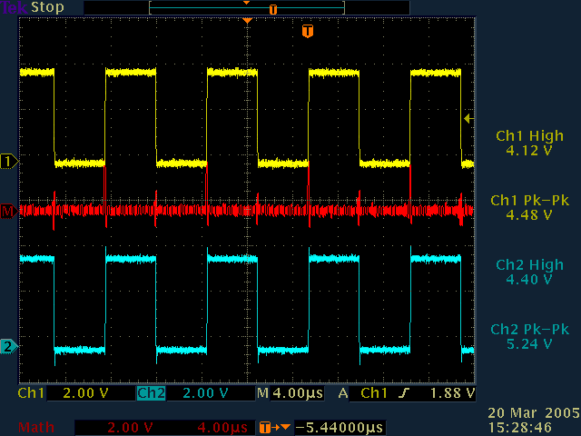
LOUTP
LOUTN1
LOUTP-LOUTN

Figure 4 CH1=LOUTP CH2=LOUTN WHEN PDWN Is Low and No signal is input

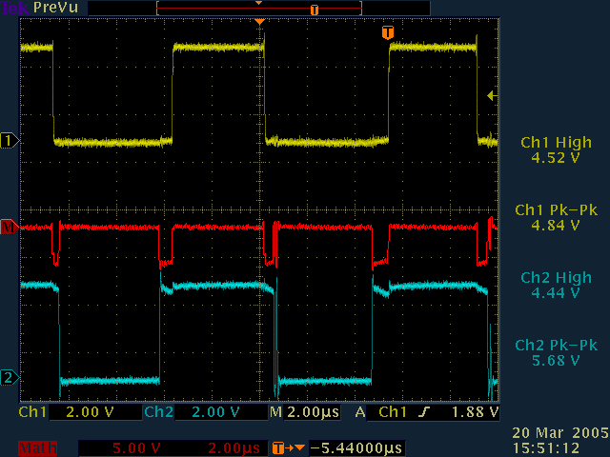
LOUTP
LOUTP-LOUTN
LOUTN1

Figure 5 CH1 LOUTP CH2 LOUTN WHEN PDWN Is low and Music Signal is input

From figure 3,figure 4 and figure 5,conclusins can be drawn below :

(1)When PDNB is connected to high,SM6802 is in power-down mode, LOUTP and LOUTN are almost zero level ;

(2)When PDNB is in low level, there is impulse on LOUTP and LOUTN.
When the input signal is floated, there is impulse on LOUTP and LOUTN, and the signal on LOUTP and LOUTN are almost the same ;But when the input signal is music signal, there is impulse on LOUTP and LOUTN, and the signal on LOUTP and LOUTN are different, the different of LOUTP and LOUTN will make the speaker play song(input signal is music).

Conclusion

According test and analysis, conclusions can be drawn below:

(1)Consumption when SM6802 in power-down mode is 0.44mA, this consumption is too big.
(2)There is much noise when using demo board to amplify the music.

